**Unpack the Ottomans**

*By Jonathan Jones*

Blowing away the Christian cobwebs of Christmas comes a stun­ning exhibition of Islamic an, from manuscripts to magic carpets. The new year blockbuster is full of treasures from collections in Istanbul, from the armored kaftan of Mehmet the Conqueror to doors designed by the great 16th-century architect Sinan for the harem of Murat III. 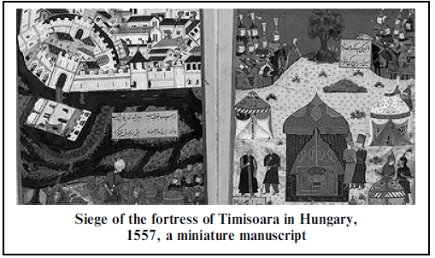

Al the beginning of the 16‘h century, Leonardo da Vinci and Michelangelo competed for one of the most lucrative commissions of the Renaissance — to build a bridge in Istanbul.

Agents of Sultan Bayezid II approached both Tuscan geniuses about their thoughts on how to connect Constantinople, the old Byz­antine capital conquered by the Ottomans in 1453, with Pera, across the Golden Horn. It never happened, but the fact that both artists ap­parently considered leaving Christendom to work for an Islamic empire epitomises the peculiar intimacy between Turks and Europeans 500 years ago.

The Ottoman Empire was colossally powerful. Il invaded not just the Balkans as far as the Danube but large parts of what are now Iraq and Iran; after Christian Constantinople had fallen, to southern Euro­peans, especially in Italy, it seemed as if they were next.

This menacing and fascinating power was the creation of the Turcomans, nomadic tribes driven gradually westwards in the middle ages by the Mongol invasions. The Turcomans migrated from central Asia to Iran and into eastern Anatolia until in the 13th century they reached the mountains of western Anatolia.

They declared a Holy War on Byzantium, the eastern relict of the Roman Empire; war bonded the nomads and gave rise to the Ottoman slate, which achieved imperial glory when Constantinople became an Islamic city.

Ottoman art ranges from beautiful illuminated books to the great Istanbul mosques of Sinan. Architect of Suleyman the Magnificent Sinan designed mosques that openly emulate and rival the great ancient Roman build­ing that dominated Constantinople, the church of Aya Sofya.

This readiness tо learn from Christian architecture is typical of the pluralism of Ottoman culture in its golden age: if Europeans were happy to come here, Istanbul was happy to have them. A pavilion in the Italian Renaissance style, with murals by Gentile Bellini, was planned for the gardens of the Topkapi Palace; Bellini also portrayed Mehmet II, conqueror of Constantinople.

The Ottomans soaked up Persian influences, loo. The elegant beauty of medieval Persian art pervades Ottoman culture, for example in book design. The most exportable products of Anatolian craftsmen themselves, however, proved to be the woollen carpets made for local use centuries before they started being sold to Europeans in the 15th century.

The symmetrical abstract luxury of these gorgeous carpets was alien to Christian tradition — which is compulsively figurative — and Turk­ish carpels were prized. They appear in so many Renaissance paintings that the classic designs are named after the artists who depicted them — Holbein, Crivelli, Bellini, Memlingand Lotto.

Turks at the Royal Academy offers the chance to bask in such luxu­ries, and to discover one of the world’s most creatively porous cultures.

*The Guardian, January, 2005*